Hart Publishing is delighted to give you information about their latest title

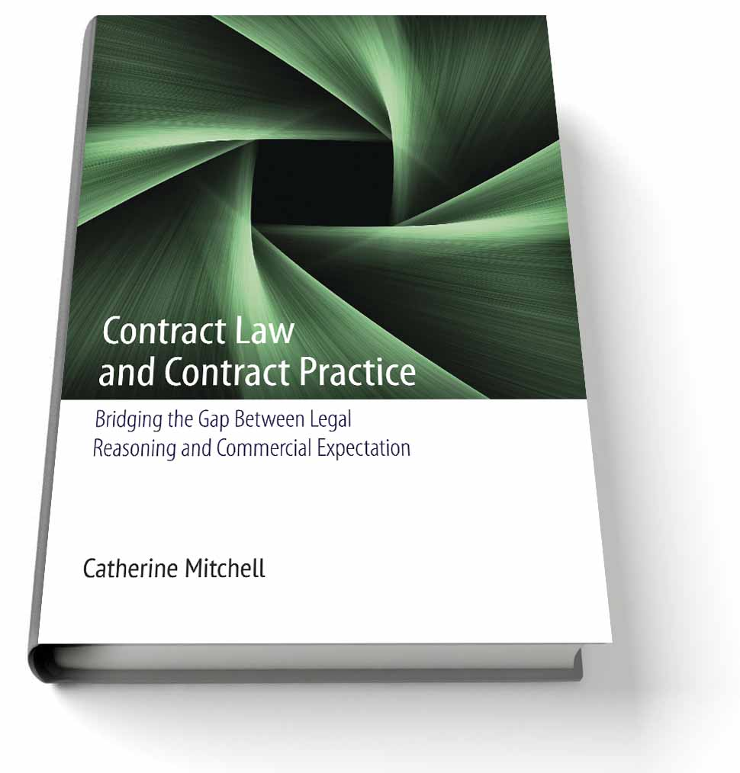
Contract Law and Contract Practice
Bridging the Gap Between Legal Reasoning
and Commercial Expectation
By Catherine Mitchell

An oft-repeated assertion within contract law scholarship and cases is that a good contract law (or a good commercial contract law) will meet the needs and expectations of commercial contractors. Despite the prevalence of this statement, relatively little attention has been paid to why this should be the aim of contract law, how these 'commercial expectations' are identified and given substance, and what precise legal techniques might be adopted by courts to support the practices and expectations of business people. This book explores these neglected issues within contract law. It examines the idea of commercial expectation, identifying what expectations commercial contractors may have about the law and their business relationships (using empirical studies of contracting behaviour), and assesses the extent to which current contract law reflects these expectations. It considers whether supporting commercial expectations is a justifiable aim of the law according to three well-established theoretical approaches to contractual obligations: rights-based explanations, efficiency-based (or economic) explanations and the relational contract critique of the classical law. It explores the specific challenges presented to contract law by modern commercial relationships and the ways in which the general rules of contract law could be designed and applied in order to meet these challenges. Ultimately the book seeks to move contract law beyond a simple dichotomy between contextualist and formalist legal reasoning, to a more nuanced and responsive legal approach to the regulation of commercial agreements.

Catherine Mitchell is a Reader in Law at the University of Hull.

Please click here to view the table of contents for this book

December 2013 308pp Hbk 9781849461214 RSP: £50 / €65
Discount Price: £40 / €52 (+Postage and Packing)

As a member of the Obligations Discussion Group Hart Publishing is delighted to offer you 20% discount.
ORDER ON-LINE
Please click here to order online. When ordering online please type the reference 'ODG' in the voucher code field and click ‘apply’ to receive the discount.

Alternatively, please contact Hart Publishing and quote reference ‘ODG’ to receive the 20% discount.
Hart Publishing Ltd, 16C Worcester Place Oxford OX1 2JW, UK
Tel: +44 (0)1865 517530 Fax: +44 (0)1865 510710
E-mail: mail@hartpub.co.uk; Website: http://www.hartpub.co.uk

